**Generating CSV for Zoom Breakout Rooms**

1. Write and save a .txt file that specifies groups and members (see below)
   1. Save this file as group.txt in the same directory as the .py file

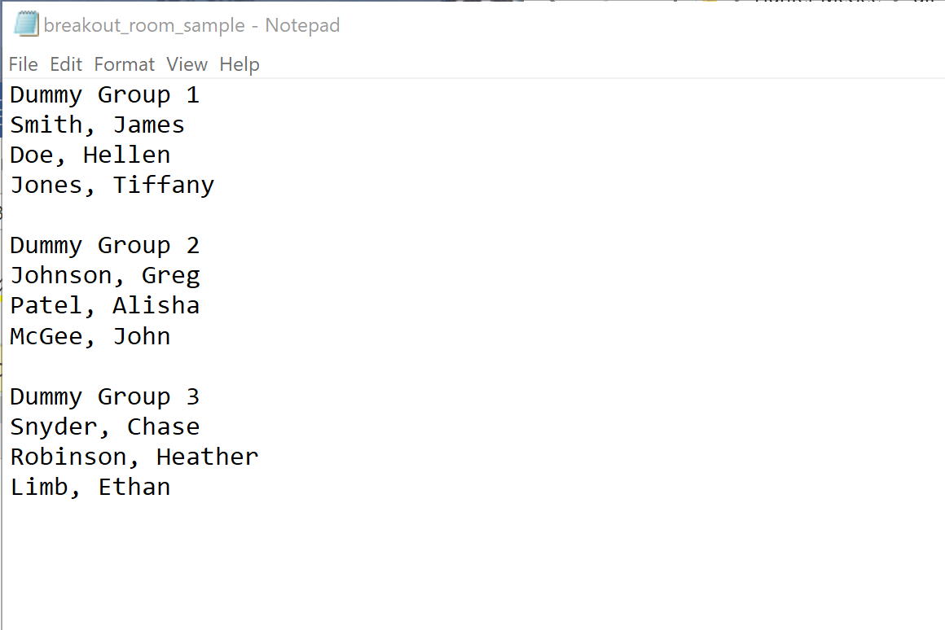

**Names must be identical to how they appear on D2L classlist.**

1. Save classlist website as classlist.html
   1. Go to the D2L course page
   2. Click on “Communication” drop-down menu
   3. Select “Classlist”
   4. Right-click on a blank area, and select “Save as”
   5. Name the file “classlist.html”, save to same directory as the first .txt file
2. Run python script by typing “python generateGroupsCsv.py” in command line.
3. Open “groups.csv” and make sure everything is saved properly.
   1. If a cell looks like ‘** LastName – FirstName **’, then either the student is not on the course roster or the names do not align between the two files.

